Ideation Phase
Define the Problem Statements

Date | 22nd May 2025
Team ID | LTVIP2025TMID55604
Project Name | Learn Hub
Maximum Marks | 2 Marks

Customer Problem Statement Template:
Create a problem statement to understand your customer's point of view. The Customer Problem Statement template helps you focus on what matters to create experiences people will love.
A well-articulated customer problem statement allows you and your team to find the ideal solution for the challenges your customers face. Throughout the process, you’ll also be able to empathize with your customers, which helps you better understand how they perceive your product or service.

Reference: https://miro.com/templates/customer-problem-statement/
Example:
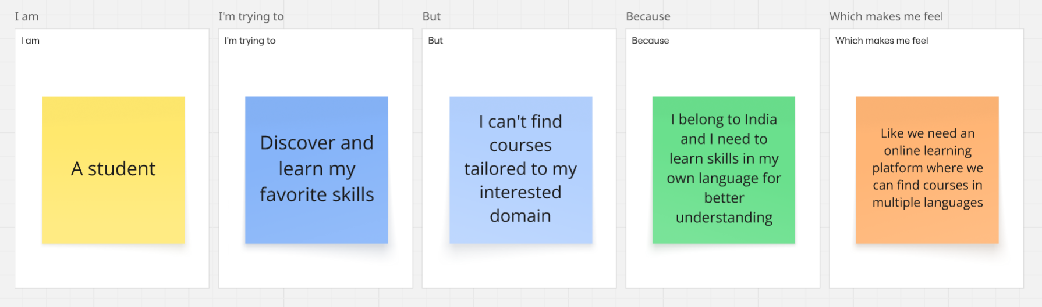

Problem Statement (PS) | I am (Customer) | I’m trying to | But | Because | Which makes me feel
PS-1 | A college student | To learn latest technologies | I can’t find relevant courses near me | I stay in a remote village in India | Like we must have an online learning platform that helps me learn skills I want in language I wish
PS-2 | A trainer | Offer training session at very affordable prices to learners | Most online learning platforms are charging much | They contain courses created by educators who charge very high | Like we need an online learning platform where individual educators who teach at affordable prices can create courses

